**保险申请和变更流程**

**Workflow for Insurance Application and Change**

申请人员填写“境外意外伤害及紧急救援医疗保险申请/变更表”并由主管签字。

The business-trip applicant should fill out the *Overseas Accident and* *Emergency Health Assistance Insurance Application/Change Form* andget it signed by authorized manager.

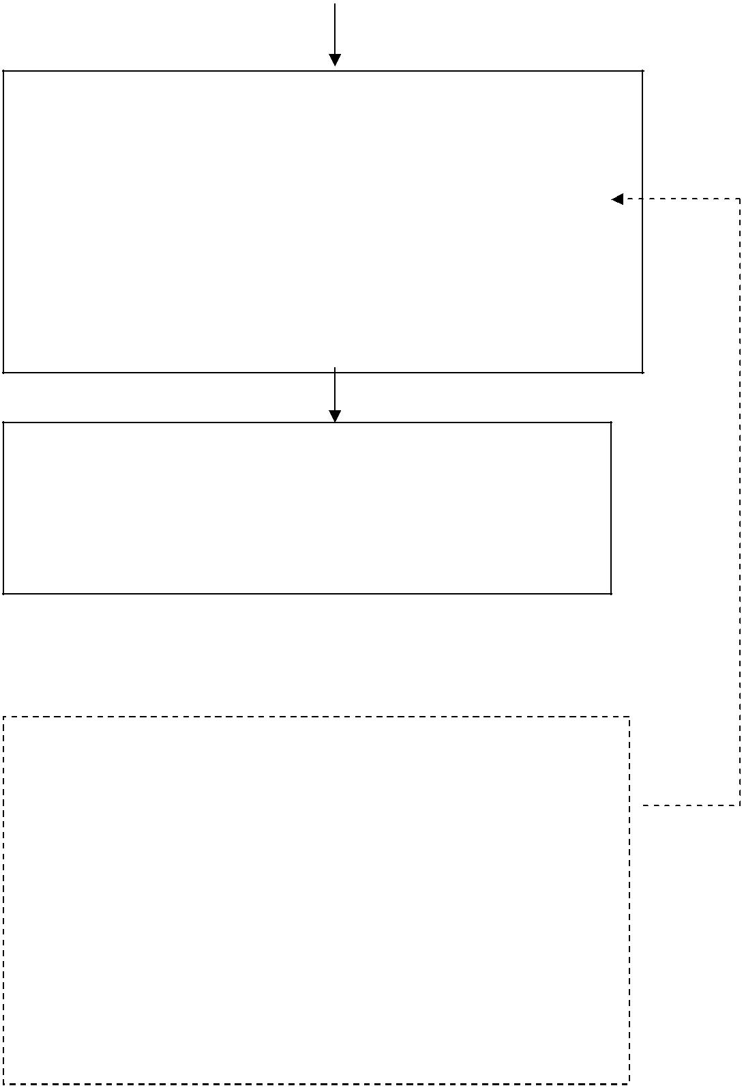

将表格扫描件以邮件形式发送到 AIG 邮箱：

**Siemens_Travel@aig.com**

若有保单原件需求，请在邮件中告知。

Send scan copy of signed form via e-mail to the Insurer:

**Siemens_Travel@aig.com**

Please let us know if you need the original copy of the certificate.

AIG 将在收到资料后的 1 个工作日内提供彩色电子版保险凭证或纸质原件（3 个工作日内）给出差申请人员。

AIG Insurance Company will provide the color e-policy to each applicant within one working day and/or the original certificate within three working days after receiving all the materials.

若被保险人提前返回，按返回后书面通知终止保单；若行程有更改，可在原定出行日期前一天通知取消保单；上述更改均需填写

“境外意外伤害及紧急救援医疗保险申请/变更表” 并由主管签字。

The Policy can be ended according to the written notice from the Insured, if returns before the expiry date of the Insurance; and can also be cancelled one day before the effective date of the Insurance, if the Insured’s schedule changes. For changing application, the *Overseas Accident and Emergency Health Assistance Insurance Application/Change Form* should be filled out with signed approvalfrom authorized manager.

**Overseas Accident and Emergency Health Assistance Insurance Application/Change Form**

**境外意外伤害及紧急救援医疗保险申请/变更表**

**公司名称 Company Name：**

* Siemens Ltd., China SC01 □SC02 □SC03 □SC04 □SC05 □SC06 □SC07 □SC08 □SC11 □SC13 □SC14 □SC16 □SC18 □SC20 □SC21 □SC24 □SC26 □SC29 □SC2A □SC31 □SC38 □SC44 □SC53 □SC57

|  |  |  |  |  |  |  |  |  |  |  |  |  |  |  |  |  |  |  |  |  |  |  |  |  |
| --- | --- | --- | --- | --- | --- | --- | --- | --- | --- | --- | --- | --- | --- | --- | --- | --- | --- | --- | --- | --- | --- | --- | --- | --- |
| ◻ | Siemens International Trading (Shanghai) Co., Ltd. (SITL) | | | | | | | |  |  |  |  | ◻ Siemens Factory Automation Engineering Ltd. (SFAE) | | | | | | | | | | |  |
| ◻ | Siemens Building Technologies (Tianjin) Ltd. (SBT) | | | | | | | |  |  |  |  | ◻ Siemens Electrical Drives Ltd. (SEDL) | | | | | | | | |  |  |  |
| ◻ | Siemens Building Technology. (Shanghai) | | | | | | | |  |  |  |  | ◻ Siemens Transformer (Jinan) Company Ltd. (STCL) | | | | | | | | | | |  |
| ◻ | Siemens Financial Leasing Co., Ltd. (SFLL) | | | | | | | |  |  |  |  | ◻ Trench High Voltage Products Ltd., Shenyang (THVS) | | | | | | | | | | |  |
| ◻ | Siemens Wind Power Blades (Shanghai) Co., Ltd. (SWPB) | | | | | | | |  |  |  |  | ◻ MWB (Shanghai) Co., Ltd. (MWB) | | | | | | | | |  |  |  |
| ◻ | Beijing Siemens Cerberus Electronic Ltd. (BSCE) | | | | | | | |  |  |  |  | ◻ Siemens Circuit Protection Systems Ltd., Shanghai (SCPS) | | | | | | | | | | |  |
| ◻ | Siemens Healthcare Diagnostics (Shanghai) Co., Ltd. (SHD) | | | | | | | | | |  |  | ◻ Siemens Shanghai Medical Equipment Ltd. (SSME) | | | | | | | | | | |  |
| ◻ | Siemens Numerical Control Ltd., Nanjing (SNCL) | | | | | | | |  |  |  |  | ◻ Siemens Electrical Drives (Shanghai) Ltd. (SEDS) | | | | | | | | | | |  |
| ◻ | Siemens Transformer (Wuhan) Company Ltd. (STWH) | | | | | | | |  |  |  |  | ◻ Siemens Gas Turbine Components (Jiangsu) Co., Ltd.(SGTC) | | | | | | | | | | |  |
| ◻ | Siemens Shenzhen Magnetic Resonance Ltd. (SSMR) | | | | | | | |  |  |  |  | ◻ Siemens High Voltage Switchgear Co., Ltd. Shanghai (SHVS) | | | | | | | | | | |  |
| ◻ | Siemens Signalling Co., Ltd., Xi'an (SSCX) | | | | | | | |  |  |  |  | ◻ Siemens Surge Arresters Ltd. (SSAL) | | | | | | | | |  |  |  |
| ◻ | Siemens Mechanical Drive Systems (Tianjin) Co., Ltd. (SMDT) | | | | | | | | | |  |  | ◻ Siemens Sensors & Communication Ltd. (SSCL) | | | | | | | | |  |  |  |
| ◻ | Siemens Industrial Automation Ltd., Shanghai (SIAS) | | | | | | | |  |  |  |  | ◻ Siemens X-Ray Vacuum Technology Ltd., Wuxi (SXVT) | | | | | | | | | | |  |
| ◻ | Siemens Power Automation Ltd. (SPA) | | | | | | | |  |  |  |  | ◻ Siemens Industry Software (Shanghai) Co., Ltd. (SISW) | | | | | | | | | | |  |
| ◻ |  |  |  |  |  |  |  |  |  |  |  |  | ◻ | Siemens Standard Motors Ltd., Yizheng (SSML) | | | | | | | |  |  |  |
| **√** Smart Metering Solutions (Changsha) Co., Ltd. (SMSC) | | | | | | | | |  |  |  |  |  |  |  |  |
| ◻ Siemens Switchgear Ltd., Shanghai (SSLS) | | | | | | | | |  |  |  |  | ◻ Siemens Wiring Accessories Shandong Ltd. (SWAS) | | | | | | | | | | |  |
| ◻ Siemens Power Plant Automation Ltd. (SPPA) | | | | | | | | |  |  |  |  | ◻ Siemens Traction Equipment Ltd., Zhuzhou | | | | | | | | |  |  |  |
| ◻ Siemens Manufacturing and Engineering Centre Ltd. (SMEC) | | | | | | | | | | |  |  | ◻ Siemens Special Electrical Machines Co., Ltd(SEML) | | | | | | | | | | |  |
| ◻ | Siemens Transformer (Guangzhou) Co., Ltd. (STGZ) | | | | | | | |  |  |  |  | ◻ Siemens Venture Capital Co,ltd.427p | | | | | | | | |  |  |  |
| ◻ Siemens Electrical Apparatus Ltd., Suzhou (SEAL) | | | | | | | | |  |  |  |  | ◻ Siemens Technology Development Co., Ltd. (STDC) | | | | | | | | | | |  |
| ◻ Siemens High Voltage Circuit Breaker Co., Ltd., Hangzhou (SHVC) | | | | | | | | | | |  |  | ◻ 北京西门子汽车电驱动系统（常州）有限公司 | | | | | | | | | | |  |
| ◻ Siemens Industrial Turbomachinery (Huludao) Co., Ltd. (SITH) | | | | | | | | | | |  |  | ◻ Siemens Logistics Automation Systems (Beijing) Co., Ltd | | | | | | | | | | |  |
| ◻ Siemens Medium Voltage Switching Technologies (Wuxi) Ltd. (SMVS) | | | | | | | | | | |  |  | ◻ Siemens Healthcare Ltd., (SHL) | | | | | | | | |  |  |  |
| ◻ Siemens Industry Automation Products Ltd., Chengdu (SEWC) | | | | | | | | | | |  |  | ◻ Siemens Industry Software (Shanghai) Co., Ltd.(SISW) | | | | | | | | | | |  |
| ◻ | Other Siemens Company___________________________________________(please kindly indicate your company name and company code) | | | | | | | | | | | | | | | | | | | | | | |  |
|  | |  |  |  | |  |  |  |  |  |  |  |  |  |  |  |  |  |  |  |  |  |  |  |
| **被保险人信息 Information of Insurant：** | | | | | | | | |  |  |  |  |  |  |  |  |  |  |  |  |  |  |  |  |
|  |  |  |  |  |  |  |  |  |  |  |  |  | | |  |  |  |  |  |  |  |  |  |  |
|  | Surname |  | Given name | |  |  | Name in Pinyin | |  | Sex |  | Date of birth | | |  | Phone No. | | |  |  |  | E-mail | |  |
|  | 姓 |  | 名 | |  |  | 拼音大写 | |  | 性别 |  |  | 出生日期 | |  | 联系电话 | | |  |  |  | 电子邮箱 | |  |
|  | |  |  |  | |  |  |  |  |  |  |  | | |  |  |  |  |  |  |  |  |  |  |
|  | |  |  |  | |  |  |  |  |  |  |  | | |  |  |  |  |  |  |  |  |  |  |
| Personal No. (For Siemens employee) | | | | | | | | |  |  | Cost Center | | | | |  |  |  |  |  |  |  |  |  |
| 员工号（西门子员工填写） | | | | |  |  |  |  |  |  | 费用中心 | | |  |  |  |  |  |  |  |  |  |  |  |
|  | | |  |  |  |  |  |  |  |  |  |  | | | |  |  |  |  |  |  |  |  |  |
| Department / Location | | |  |  |  |  |  |  |  |  | Destination | | | | |  |  |  |  |  |  |  |  |  |
| 部门 / 地点 | | |  |  |  |  |  |  |  |  | 出访国家 | | |  |  |  |  |  |  |  |  |  |  |  |
| Passport No. | | |  |  |  |  |  |  |  |  | Passport Valid Date | | | | |  |  | From | | | | To | |  |
| 护照号码 | | |  |  |  |  |  |  |  |  | 护照有效期(年/月/日) | | | | |  |  |  |  |  |  |  |  |  |
|  | | |  |  |  |  |  |  |  |  |  |  | | | |  |  |  | | | |  | |  |
| ID No. | | |  |  |  |  |  |  |  |  | Insurance Valid Period | | | | |  |  | From | | | | To | |  |
| 身份证号码 | | |  |  |  |  |  |  |  |  | 保险有效期 (年/月/日) | | | | |  |  |  |  |  |  |  |  |  |
|  |  |  |  |  |  |  |  |  |  |  |  |  |  |  |  |  |  |  |  |  |  |  |  |  |
|  |  |  | Per-trip | |  |  | ◻ B、(RMB3.64/person/day, short distance) | | | | | | |  |  |  |  |  | 备注: | | |  |  |  |
| Insurance type | | | insurance | |  |  | ◻ C、(RMB4.46/person/day, long distance, applicable to Schengen Visa) | | | | | | | | | | | |  |  |  |
|  |  |  | | |  |  |  |
|  |  |  |  |  |  |  |  |  |  |  |  |  |  |  |  |  |  |  |  | Pls. refer to Siemens China Travel | | | |  |
| 保险类型 | | | Annual | |  |  | ◻ B、(RMB346/person/year, short distance) | | | | | | |  |  |  |  |  |  |  |
|  |  |  |  |  |  |  |  | Policy | |  |  |  |
|  |  |  | insurance* | |  |  | ◻ C、(RMB419/person/year, long distance, applicable to Schengen Visa) | | | | | | | | | | | |  |  |  |  |
|  |  |  |  |  |  | | |  |  |  |
|  |  |  |  |  |  |  |  |  |  |  |  |  | |  |  |  |  |  |  |  |  |  |  |  |
| **Relationship with policy holder (被保险人与投保人关系)：** | | | | | | | | |  |  | **√** | | |  |  |  |  |  |  |  |  |  |  |  |
|  |  | **□Employee □Business partner □Relations □Else** | | | | | | | | | | | | |  |
| **经办人信息 Information of the Issuer：** | | | | |  |  |  |  |  |  |  |  |  |  |  |  |  |  |  |  |  |  |  |  |
|  |  | |  |  |  | | |  |  | |  |  |  |  | |  |  |  | | | |  | |  |
|  | Issuer name | |  |  | Employee ID | | |  | Department | |  |  |  | Phone No. | |  |  | Fax | | | | E-mail | |  |
|  | 经办人姓名 | |  |  |  | 员工号 | |  |  | 部门 |  |  |  | 联系电话 | |  |  | 传真号码 | | | | 电子邮箱 | |  |
|  | 扶英莎 | |  |  |  | | |  |  | HR |  |  | | | |  | 0731-88619552 | | | |  |  | |  |

**申请信息变更 Application for Modification of the Insurance：**

Information of modification and reason（变更信息及原因）：

注：申请退保如为拒签原因，请同时提供领使馆拒签证明。

**签字 Signature ：**

Application date（申请日期）：

Applicant / Issuer 申请人/经办人签字：

Authorized by 部门经理签字盖章：

Signed by Insurance Company （保险公司签章）：

AIG Insurance Company China Limited Beijing Branch（美亚财产保险有限公司北京分公司）Responsible person：AIG 服务中心

E-mail：**Siemens_Travel@aig.com** Hotline：400-820-8858

*frequent travelers (i.e. who expect accumulated days on Siemens overseas biz travel in next continuous 12 months will exceed 94 days) may consider to purchase annual

insurance.

**海外差旅保险保障内容及限额 （人民币）**

**Overseas Business Travel Insurance Coverage (in RMB)**

|  |  |  |
| --- | --- | --- |
| **每人保险金额（即赔付上限）** | **Plan B** | **Plan C** |
| **Maximum Sum Insured Per Insured Person** |  |  |
| **意外身故/残疾/烧烫伤** | 300,000 | 300,000 |
| **Accidental Death, Burns & Dismemberment** |  |  |
| **急性病身故** | 300,000 | 300,000 |
| **Travel Acute Disease Death** |  |  |
| **医疗费用** | 200,000 | 350,000 |
| **Medical Expenses** |  |  |
| **医疗运送和送返** | 200,000 | 500,000 |
| **Emergency Medical Evacuation** |  |  |
| **身故遗体送返** | 100,000 | 200,000 |
| **Repatriation of Remains** |  |  |
| **个人随身财产（每件物品限额 500 元，手提电脑 3,000 元）** | 6,000 | 6,000 |
| **Personal Property (Limit to RMB 500/article，Laptop RMB 3,000)** |  |  |
| **个人第三者责任** | 100,000 | 100,000 |
| **Personal Liability** |  |  |

B 类保险：B 类保险将用于员工短途境外差旅。Plan B is for short distance overseas business travel. C 类保险：C 类保险将用于员工长途境外差旅。Plan C is for long distance overseas business travel. 在一个保险年度内，如果累计差旅天数超过 94 天,保险公司将按照年单保费计算。

If the accumulated insurance days (per-trip type) within one Insurance policy year (Oct 1 st this year to Sep 30th of next year) are over 94 days, Insurance company will calculate the cost according to annual insurance premium automatically.

短途和长途境外差旅的概念请参考差旅政策。Pls. refer to SLC Travel Policy for definition of short distance and long distance overseas business travel.

|  |  |  |
| --- | --- | --- |
|  | **Contact Information** | |
|  | **保险联系人** | |
|  |  |  |
| 首选联系人/First Support |  | 次选联系人/Second Support |
| AIG 北京－服务中心（申报\Declaration） |  | AIG- Sam Li 李军（协调\ coordinator） |
| 联系电话：400-820-8858 |  | 联系电话：400-820-8858 |
| 邮箱：**Siemens_Travel@aig.com** |  | 邮箱： Sam-J.Li@aig.com; |
| AIG Beijing: AIG Service Center |  |  |
| Phone: 400-820-8858 |  |  |
| Email: **Siemens_Travel@aig.com** |  |  |